**Revision History**



DoH Policies and Standard System

[Business Requirement Document]

|  |  |  |  |  |
| --- | --- | --- | --- | --- |
| **Date** | **Version** | **Description** | **Author/Reviewer** | **Status** |
| 27/03/2019 | V0.1 | Initial Draft | Satyanarayan Maurya | Draft |
| 03/07/2019 | V1.0 | Final Update | Satyanarayan Maurya | Completed |
| 17/07/2019 | V1 | Updated with the final business comment | Satyanarayan Maurya | Completed |
|  |  |  |  |  |
|  |  |  |  |  |
|  |  |  |  |  |

Contents

1. Introduction 5

1.1. Purpose of This Document 5

1.2. Scope of This Document 5

1.3. Design Considerations 5

1.4. Assumptions and Dependencies 5

1.5. Requirement Levels 5

2. Project Overview 6

2.1. Project Overview & Background 6

2.2. Project Stakeholders 6

2.3. Key Assumptions & Constraints 6

3. Participants & Data Accessibility 7

4. Business Requirements 8

4.1. Requirements 8

4.2. Business Rules [manual tasks will be out of scope of this project] 10

4.3. Notifications / Alerts Requirements 11

4.4. SMS/EMAIL Text 11

4.5. Process Diagrams: 12

4.5.1. Application Status flow: 13

4.5.2. Policy and Standards team’s internal process: 14

5. Mockups 15

5.1. DoH Internal Staff view: 15

5.2. External User View: 15

5.3. New / Update Request: 16

5.4. Delete Request: 17

5.5. Project View 18

5.6. Update Project Tasks: 19

5.7. Initiate User Feedback 19

5.8. Internal User Policy Feedback (only DoH users) 19

5.9. External User Policy Feedback (no login needed) 20

5.10. Search Requests 21

5.11. Project Search 21

5.12. Email Template 22

6. Glossary 23

7. Appendix 24

7.1. Project Type 24

7.2. Project Status 25

7.3. Project Phase KPI 25

8. Approvals Sign off 26

8.1. Healthcare Policy and Standards (Requestor) 26

9. Approvals Sign off 27

9.1. Healthcare Policy and Standards (Section Head/ Manager) 27

10. Approvals Sign off 28

10.1. Healthcare Policy and Standards (Director) 28

11. Review Sign offs 29

11.1. Business Application Section Head 29

# Introduction

## Purpose of This Document

This document describes the business requirements of **Policies and Standards Portal**.

## Scope of This Document

This document explains the Business Requirements for the **Policies and Standards Portal**. It describes the functions, goals, and tasks that the system should support or perform. This document comprises of vision, business process flows, business level requirements, and Business rules

## Design Considerations

## Assumptions and Dependencies

Following are the assumptions and dependencies regarding this project/ process:

* The End user/Customer has communicated all the business requirements to IT-DoH.
* There will be no significant changes to the requirements during the development process.

## Requirement Levels

The requirements set out in this document may have one of the three following levels

”Essential” This level means that the definition is an absolute requirement of the specification.

“Recommended” This level means that there may exist valid reasons in particular circumstances to ignore a particular item, but the full implications must be understood and carefully weighed before choosing a different course.

“Optional” This level means that that an item is truly optional*.*

# Project Overview

## Project Overview & Background

The Healthcare policy and standards department of DoH is responsible for developing and managing (i.e. adding, updating, deleting, etc.) the policies and standards. Currently, the entire process of managing their tasks are manual which is time consuming. In order to visualize, prioritize and organize their task, they need an online portal to receive requests related to healthcare policies and standards and a platform to manage their work.

This project aims to automate the current manual process by providing an online portal to receive requests, manage tasks, receive feedback, create and manage projects, etc.

## Project Stakeholders

| **S. No.** | **Stakeholders** | **Department/**  **Section** | **Internal/**  **External** |
| --- | --- | --- | --- |
| 1. | Mahasen Ali Al Hosani | Sr. Officer Healthcare Policy & Standards, Healthcare Policy and Standards | Internal |

## Key Assumptions & Constraints

|  |  |
| --- | --- |
| **#** | **Assumptions** |
| 1. | There would not be any major/significant requirement changes during development phase. |
| 2. | Business user will provide the text changes in both languages i.e. English and Arabic. |
| 3. | Business user will arrange the training for the staffs about the new changes. |
| 4. | All users (internal or external) has informed and trained on the changes by Business Stakeholders. |
| 5. | Business users perform the full UAT testing before deployment. |
| # | Constraints |
| 1. | Project cannot go live unless Business team performs full UAT testing and provides the UAT sign off. |

# Participants & Data Accessibility

The following table lists the application participants and the level of accessibility they should be allowed:-

| **S. No.** | **Web Page** | **Actors/Users** | **Designation/Role** | **Organization** | **Data Access** | **Description** |
| --- | --- | --- | --- | --- | --- | --- |
| 1. | PS_User | End User | Internal / External | END USER | Add, View, Edit | Can submit the application related to policies and view the status. |
| 2. | PS_Offier | DoH User | Policies and Standards Team | DoH | Add, View, Edit | Can view all submitted application and create project if needed. |
|  | PS_Manager | DoH User | Policies and Standards Team | DoH | Add, View, Edit | Can assign an application or project to any officer. |

**Data Access**: *View, Add (Save/Submit), Edit (Update)*

*.*

# Business Requirements

## Requirements

| **BN No.** | **Requirement Type** | **Requirements Description** | **Requirement Levels** | **Current Status** |
| --- | --- | --- | --- | --- |
| BN1 | Business Requirement | The end users should be able to submit the request. | *Essential* | Required |
| BN2 | Business Requirement | DoH Internal staff should submit the below information as mentioned in #DoH Internal Staff view:   * Internal (DOH division/ employee) * Division * Department * Section * Employee Number: * Ext: | *Essential* | Required |
| BN3 | Business Requirement | DoH External staff should submit the below information as mentioned in #External User View:   * External (Community member) * Facility/ Workplace: * Job Position: * Contact Details: * Email: * Mobile: | *Essential* | Required |
| BN4 | Business Requirement | User must select at least on request type to proceed submitting more information. Once the request type submitted, it should not be changes. | *Essential* | Required |
| BN5 | Business Requirement | For request type “New” and “Update”, the form should open to submit as mentioned in #New / Update Request: | *Essential* | Required |
| BN6 | Business Requirement | For request type “Delete”, the form should open to submit as mentioned in #Delete Request: | *Essential* | Required |
| BN7 | Business Requirement | Three user roles to be created as mentioned in #Participants & Data Accessibility | *Essential* | Required |
| BN8 | Business Requirement | Duration Calculation Logic:   1. **Waiting Time:** The difference between "Request Date" and "Start Date" in days 2. **Planned Duration:** The difference between "Start Date" and "Planned Completion in months 3. **Actual Duration:** The difference between "Start Date" and "Publication Date" | *Essential* | Required |
| BN9 | Business Requirement | Once the request is accepted as a project, then the Project view section should be enabled as mentioned in #Project View | *Essential* | Required |
| BN10 | Business Requirement | Users should have option to save the application in Draft status. | *Essential* | Required |
| BN11 | Business Requirement | A confirmation message should popup once the user decided to complete #DoH Internal Staff view: or #External User View: - “Please be noted that, the request type cannot be changed once submitted.” | *Essential* | Required |
| BN12 | Business Requirement | End user should have the option to cancel the request unless it was submitted. | *Essential* | Required |
| BN13 | Business Requirement | DoH PS team should have the text box to put the comments while returning the application back to requestor. | *Essential* | Required |
| BN14 | Business Requirement | Following application status should be maintained:   * Save as Draft * Submitted * Clarification Required * Work in Progress * Closed * Cancelled * Aborted   As mentioned in #Application Status flow: | *Essential* | Required |
| BN15 | Business Requirement | Application should follow the internal process sequence as mentioned in #Policy and Standards team’s internal process: and system should be maintaining the status. | *Essential* | Required |
| BN16 | Business Requirement | System should be maintaining the event log | *Essential* | Required |
| BN17 | Business Requirement | System should provide the comment box for the internal use only in #Project View | *Essential* | Required |
| BN18 | Business Requirement | Confirmation popup should appear while closing and aborting the project. | *Essential* | Required |
| BN19 | Business Requirement | Project cannot be closed until all the project tasks completed as mentioned in #Policy and Standards team’s internal process: | *Essential* | Required |
| BN20 | Business Requirement | Once, the project is assigned to any staff, no other staff should be able to take any action except viewing. | *Essential* | Required |
| BN21 | Business Requirement | History log of the each transaction on the project should be maintained and DoH PS Users should be able to view it. | *Essential* | Required |
| BN22 | Business Requirement | Officer should be able to assign the project or application to other staff. However, the justification should be mandatory in this case. | *Essential* | Required |
| BN23 | Business Requirement | User with Admin access would not need justification to assign/reassign project to any staff. | *Essential* | Required |

## Business Rules [manual tasks will be out of scope of this project]

| **Sr. No.** | **Requirement Level** | **Requirements Description** |
| --- | --- | --- |
| 1. | Essential | External user should register with DoH to submit the request. |
| 2. | Essential | Internal users should have access to submit the requests. |
| 3. | Essential | Request ID format: PS/REQ/XXXXXX/YYYY |
| 4. | Essential | Request should have option to be linked with existing project. |
| 5. | Essential | Once the project is closed, all related requests should be closed automatically with email notification to requestors. |
| 6. | Essential | Project ID reference format: PS/PRJ/XXXXXX/YYYY |
| 7. | Essential | Application should be marked as Cancelled if it is kept in “Save as Draft” for more than 30 days. |
| 8. | Essential | Only assigned person should be able to update the project details. |
| 9. | Essential | Access to submit the application, should be given automatically for all DoH registered users. |
| 10 | Essential | Application should be automatically close after 15 days of not replying on Clarification required application. History should be maintained and user with PS_Manager should be able to re-open the application. |

## Notifications / Alerts Requirements

| **Sr. No.** | **Category** | **Type** | **Receiver** | **Events** |
| --- | --- | --- | --- | --- |
|  | SMS | Request | Applicant | **Application Status: Submitted** |
|  | SMS | Request | Applicant | **Application Status: Clarification Required** |
|  | SMS | Request | Applicant | **Application Status: Closed** |
|  | EMAIL | Request | PS Mailbox | **Application Status: Submitted** |
|  | EMAIL | Request | PS Officer | **Application Status: Assigned to Officer** |
|  | SMS | Reminder | Applicant | **Application status Clarification Required for 7 days. (one time reminder)** |

## SMS/EMAIL Text

| **Sr. No.** | **Category** | **Type** | **Event[Receiver]** | **Message** |
| --- | --- | --- | --- | --- |
|  | SMS | Request | Application Submitted /Resubmitted [Applicant] | **Your Policy and Standard request <APP ID> has submitted successfully. You will be notified once any action taken on your application by the DOH Policy and Standards team.** |
|  | SMS | Request | Application Resolved/ Closed [Applicant] | **Policy and Standard team has taken action on your Policy and Standards <APP ID>.** |
|  | SMS | Request | Application Resolved/ Closed [Applicant] | **Policy and Standard team has taken action on your Policy and Standards <APP ID>.** |
|  | EMAIL | Request | Application Submitted [Admin] | **A Policy and Standards request with <APP ID> submitted and needs your attention. Click the link <Link> to view the request.** |
|  | EMAIL | Request | Application Submitted [Admin] | **A Policy and Standards request with <APP ID> assigned to you and needs your attention. Click the link <Link> to view the request.** |
|  | SMS | Reminder | Application Clarification Required  [Applicant] | **You request with <APP ID> is waiting for the action. Please login to DoH portal to complete the application.** |

## Process Diagrams:

### Application Status flow:

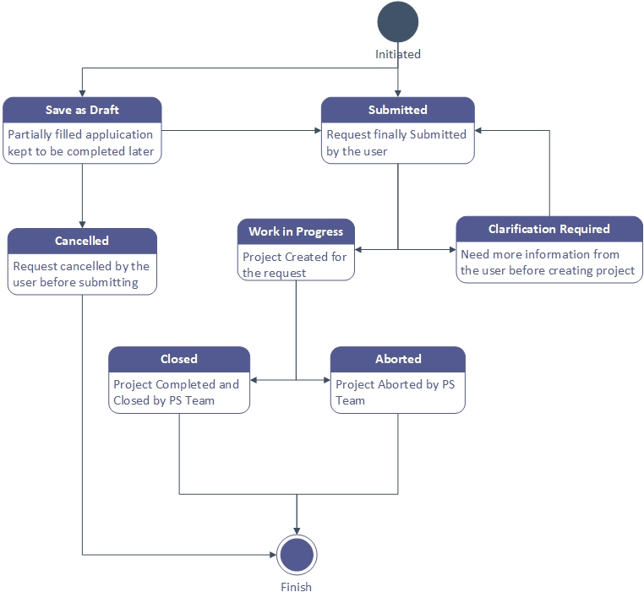

### Policy and Standards team’s internal process:

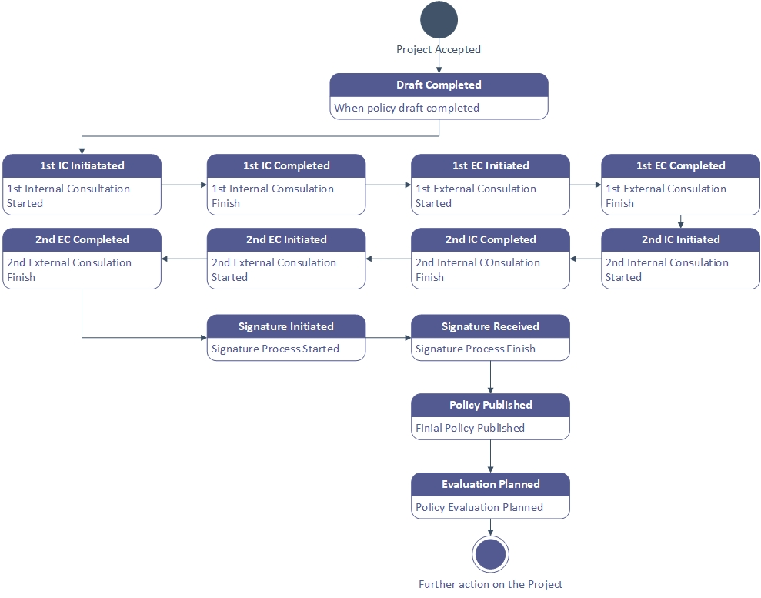

**Notes:**

Internet and Intranet portal design will be out of scope of this project. However, we will have a working link after the project implementation that will show the available projects open to receive feedback.

Portal design on internet and intranet could be achieved by contacting the Corporate Communication & Media team, as they are the owner of the internet and internet system.

# Mockups

(Note: The mockup designs are only for the reference purpose and the actual design could be little different.)

## DoH Internal Staff view:

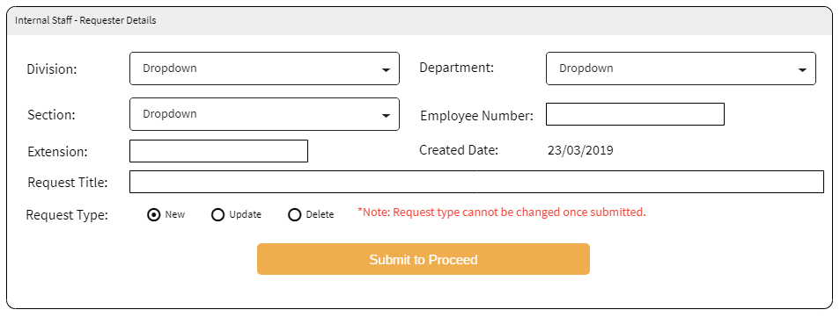

## External User View:

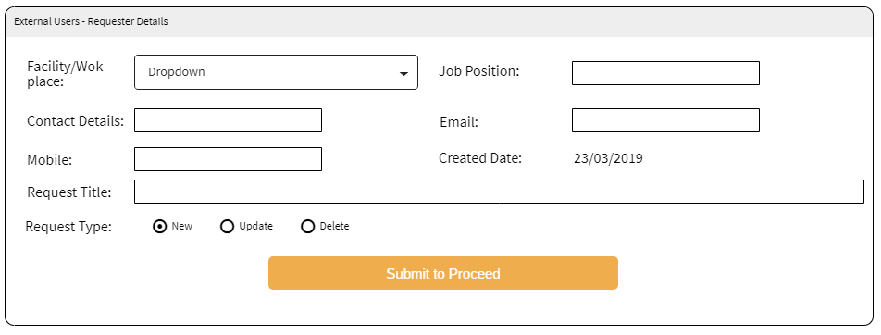

## New / Update Request:

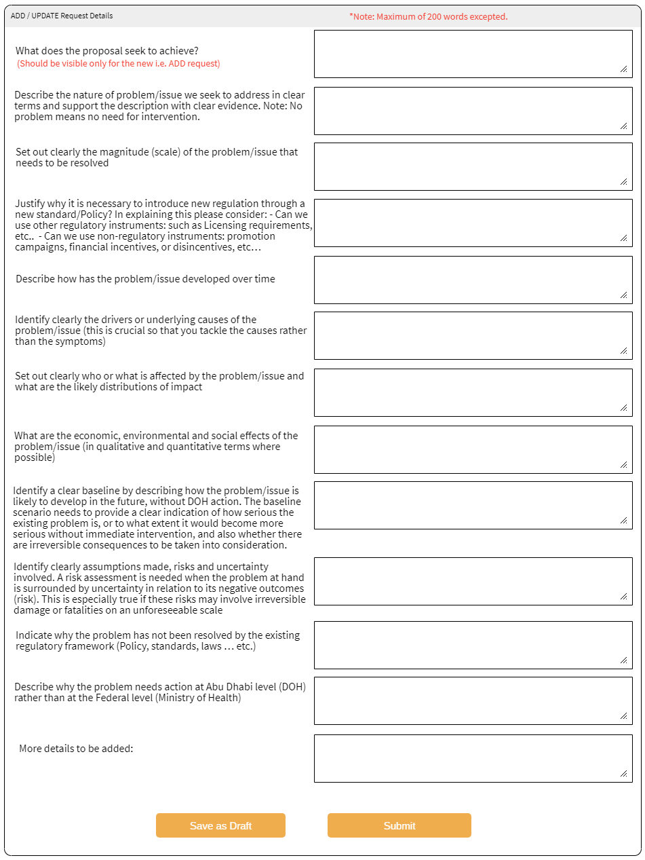

**Notes:**

1. This page will have option to **return back application, close request**, link **request with existing project** or to **create a new project**. If clicked on the “Create Project” it will open #5.5 Project View
2. All Fields will be disabled for the DoH officer.
3. Applicant’s personal information will be available for policy officer when they open this page.
4. If closed, then justification should be mandatory and the same should be visible to applicant.

## Delete Request:

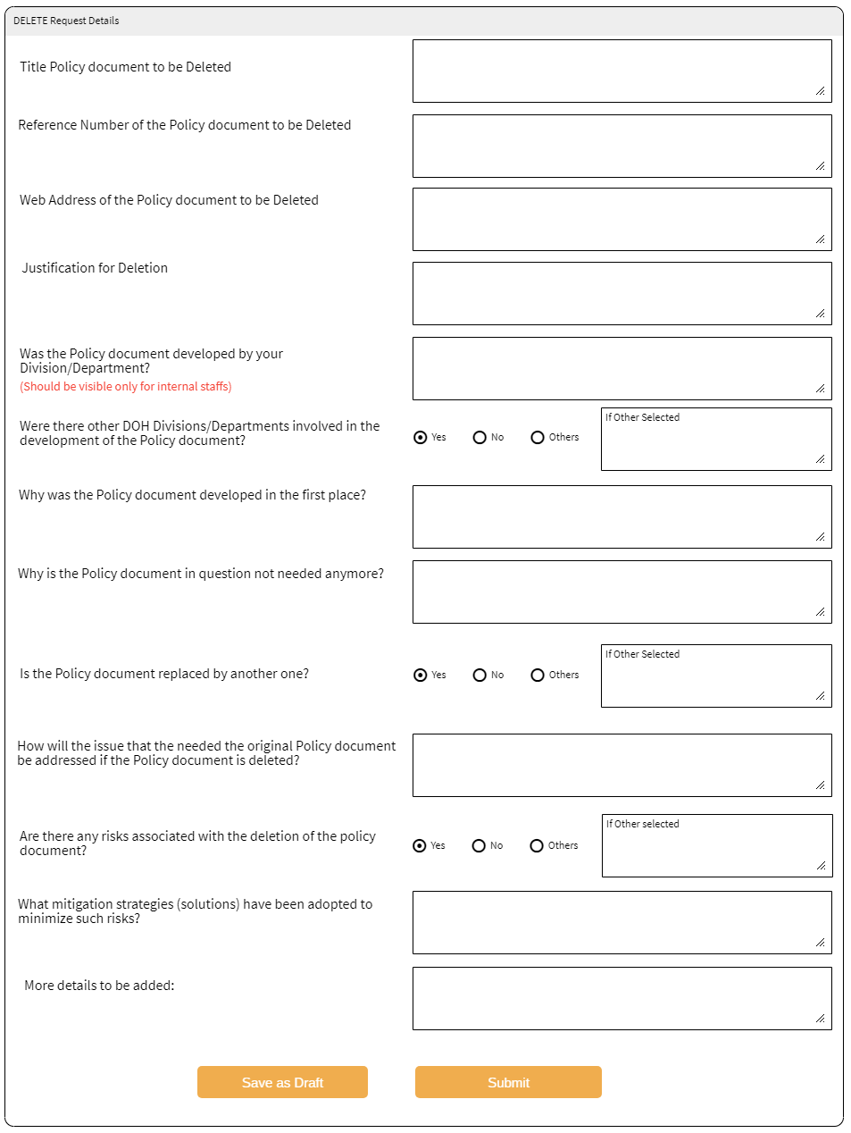

**Notes:**

1. This page will have option to **return back application, close request**, **link request with existing project** or to **create a new project**. If clicked on the “Create Project” it will open #5.5 Project View
2. All Fields will be disabled for the DoH officer.
3. Applicant personal information should be shown if officers opens this page.
4. If closed, then justification should be mandatory and the same should be visible to applicant.

## Project View

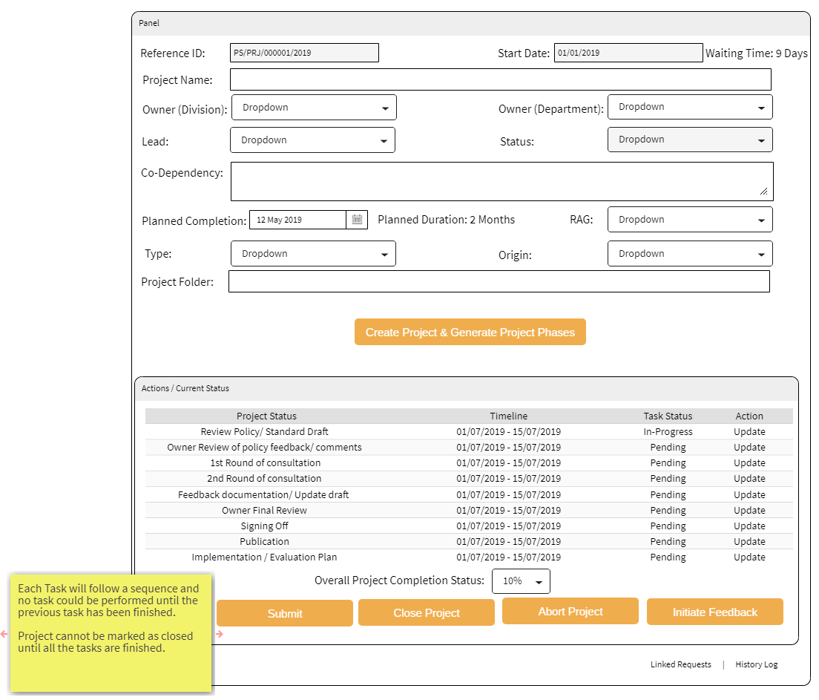

**Notes:**

1. Ownership dropdown to be added to the form and it should be populated by the staffs having PS_Officer access.
2. Overall project status is open to be selected by the officers.
3. Refer the default date setup guideline in Section #7.3 Project status KPI
4. Task status : Pending, In-Progress and Completed
5. Once a task completed, the next tasks becomes “In-Progress”.

## Update Project Tasks:

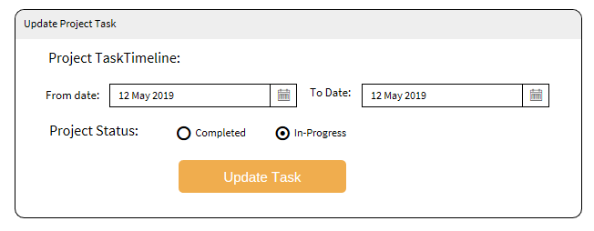

## Initiate User Feedback

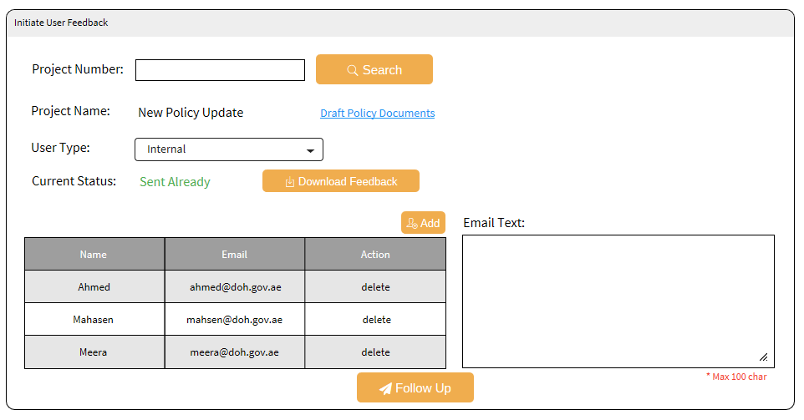

*User type: Internal and External

## Internal User Policy Feedback (only DoH users)

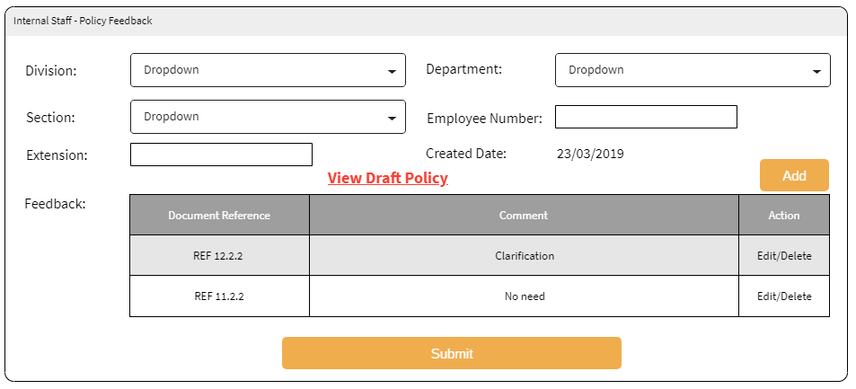

* Export in excel sheet

## External User Policy Feedback (no login needed)

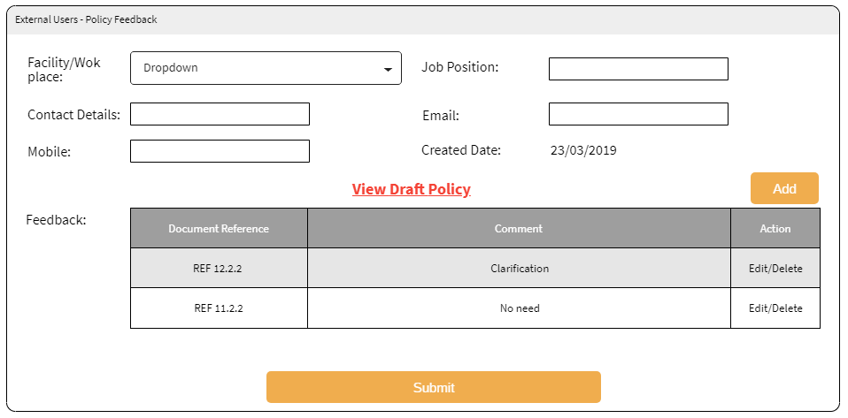

* Captcha should be there for the external user’s feedback.
* User’s name should be captured
* Export in excel feature.

## Search Requests

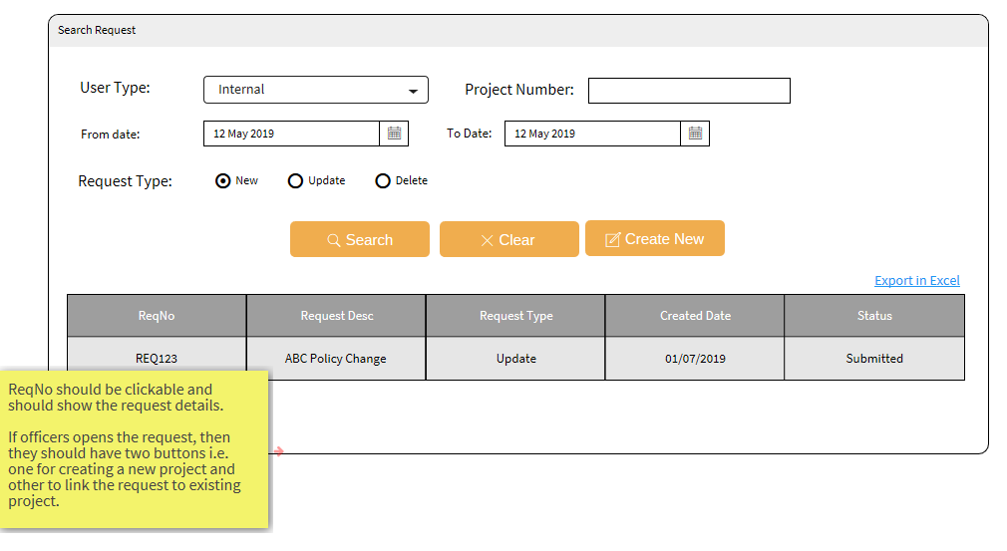

## Project Search

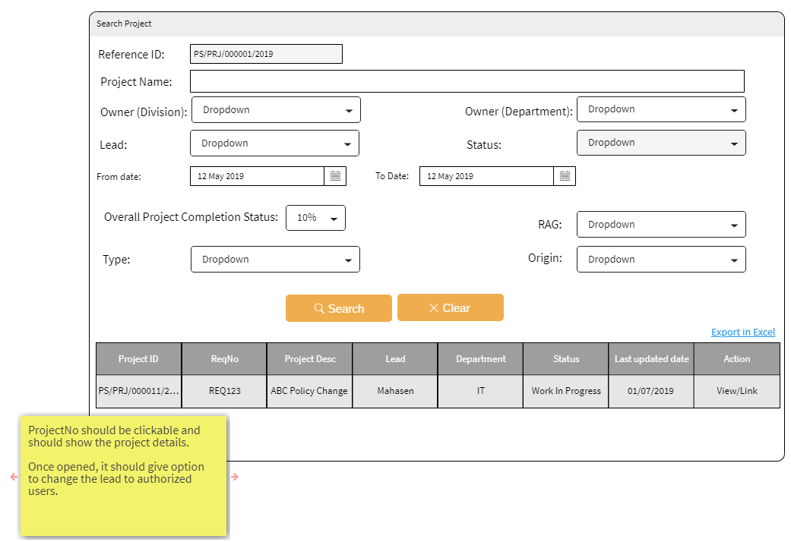

## Email Template

***To:*** *Entered email addresses*

***CC:*** *Policy and Standards Team mailbox*

Dear <User’s name>

<Text from the Request User Feedback Form>

Click on the below link to open the feedback form.

< Link to open the #Internal User Policy Feedback or #External User Policy Feedback based on type of user selected in #Initiate User Feedback >

Thank you!

Regards,

DoH | Policies and Standards Team

# Glossary

| **Term/Acronym** | **Definition** |
| --- | --- |
| BN | Business Requirement |
| UAT | User Acceptance Testing |
| DoH | Department of Health |
| PS | Policy and Standards |

# Appendix

## Project Type

|  |  |
| --- | --- |
| **Type** | **Tool Tip Text** |
| **Policy** | * Outline what DOHwants to achieve. * Reflect DOHvalues and vision. * Represent a course of action that drives the direction and priorities of DOH. * Set out DOH’S plans, decisions and actions (chosen among alternatives) to achieve its goals. * Determine the allocation of publicresources. * Have redistribution effects. * Are not limited in time and have common long-term objectives. * Require tools to achieve it: laws, regulations, standards, strategies, action plans…etc. |
| **Standard** | * Provide a consistent framework to ensure that services are of the highest quality and that they are doing the right thing, in the right way, in the right place, at the right time and with the right staff. * Add further definition around practice, establishing both acceptable minimum and aspirational levels. * Set the minimum requirements for specific structures, processes and services will define the related roles and responsibilities of Providers, Professionals and Insurers and their interactions with respect to the Standards. * Set expected level of specification, quality, or safety for products, processes, services, or performance. |
| **Guidelines** | * Piece of advice, a recommendation that is (by definition) not mandatory. |
| **Impact Assessment** | * Impact Assessment is atool to help explain the effect of any proposed intervention or policy that is expected to have an impact on different stakeholders and the health sector. It is critical for providing a systematic approach to decision making and for an understanding of the impact associated with any proposed intervention. |
| **Evaluation** | * Policy evaluation applies evaluation principles and methods to examine the implementation or impact of a policy. Evaluation is the activity through which we develop an understanding of the merit, worth, and utility of a policy.   **Types of regulatory instrument evaluation**:   * Evaluating Policy Implementation:   Was the policy implemented as intended? The implementation of a policy is a critical component in understanding its effectiveness. Evaluation of policy implementation can provide important information about the barriers to and facilitators of implementation and a comparison between different components or intensities of implementation.   * Evaluating Policy Impact:   Did the policy produce the intended outcomes and impact? Within injury prevention, the intended impact may be a reduction in injuries or severity of injuries. However, it is important to evaluate short-term and intermediate outcomes as well. |
| **Program specification** | * Provide a consistent framework to ensure that DoH funded programs are provided at the highest quality, in the right way, in the right place, at the right time and by the right staff. * Set the minimum requirements for the programs specific structures, and processes. * Define the related roles and responsibilities of Providers, Professionals and Insurers and their interactions with respect to the Program Specification. |
| **Other** |  |

## Project Status

|  |
| --- |
| **Status** |
| Submitted |
| Save as Draft |
| Cancelled |
| Aborted |
| Work In Progress |
| Closed |
| Clarification Required |

## Project Phase KPI

|  |  |  |  |
| --- | --- | --- | --- |
| **Ser.** | **Project phases** | **Time Frame** | **Notes** |
| 1 | Review Policy/ Standard Draft | Two weeks | From the moment of creating Project |
| 2 | Owner Review of policy feedback/ comments | Two weeks | There should be option to change the dates manually and next phase dates should adjust.  Changing date should not be applicable on tasks, which are already closed. |
| 3 | 1st Round of consultation | Two weeks |
| 4 | 2st Round of consultation | Two weeks |
| 5 | Feedback documentation/ Update draft | Three weeks |
| 6 | Owner Final Review | Two weeks |
| 7 | Signing Off | Two weeks |
| 8 | Publication | Two weeks |
| 9 | Implementation / Evaluation Plan | Two weeks | Final stage and project will be marked closed once this step completed. |

# Approvals Sign off

## Healthcare Policy and Standards (Requestor)

I have reviewed the above stated Business requirements of **Policies and Standards Portal.** I hereby give you approval to proceed to develop the new system.

I understand that further changes to the Business requirements, Business rules or Business process will likely result in a delay in the final delivery date.

**Name : Mahasen Ali Al Hosani**

**Designation :** Sr. Officer

**Section :** Healthcare Policy & Standards

**Department :** Healthcare Policy and Standards

___________________________________

**Signature:**

**Date:** ______________________________

# Approvals Sign off

## Healthcare Policy and Standards (Section Head/ Manager)

I have reviewed the above stated Business requirements of **Policies and Standards Portal.** I hereby give you approval to proceed to develop the new system.

I understand that further changes to the Business requirements, Business rules or Business process will likely result in a delay in the final delivery date.

**Name : Dr. Zainab Nader khazaal**

**Designation :** Department Manager

**Section :** Healthcare Policy & Standards

**Department :** Healthcare Policy and Standards

**Division** : Strategy

___________________________________

**Signature:**

**Date:** ______________________________

# Approvals Sign off

## Healthcare Policy and Standards (Director)

I have reviewed the above stated Business requirements of **Policies and Standards Portal.** I hereby give you approval to proceed to develop the new system.

I understand that further changes to the Business requirements, Business rules or Business process will likely result in a delay in the final delivery date.

**Name : Dr. Hamed Ali Al Hashemi**

**Designation :** Director

**Section :** NA

**Department :** NA

**Division :** Strategy & Corporate Performance

___________________________________

**Signature:**

**Date:** ______________________________

# Review Sign offs

## Business Application Section Head

I have reviewed the Business requirements of **Policies and Standards Portal.** I hereby give you approval to proceed to develop the new software process.

**Name : Noura Jumaa Al Meraikhi**

**Designation :** Section Head

**Section :** Business Applications

___________________________________

**Signature:**

**Date:** _______________________